**Online Training Instructions for New Personnel in Animal Labs**

**Log-in Instructions for the CITI Courses:**

* **University of Oregon Introduction to Animal Research**
* **University of Oregon Introduction to Survival Surgery**
* **University of Oregon Occupational Health and Safety for Working with Animals**

1. Navigate to [citiprogram.org](https://urldefense.com/v3/__https:/citiprogram.org/__;!!C5qS4YX3!V2tshmyCG8bl53n8TWr5QANiqfDvrJKrSJbpM-Za5E3EvIxUjIJcegiNC0fK7OJu$)
2. Click “**Log in**” in the upper right corner.



1. Select **“Log in through my organization”** (Do not set up an individual account at this step)

1. Enter **University of Oregon**. You will then be directed to your standard Duck ID log-in.

1. You will be asked to create an account if it is the first time you’ve logged into CITI.

1. Select **View Courses** next to your organization

1. Scroll all the way to the bottom of the page
2. Within the Learner Tools grey box, Select "**Add a Course**"

1. Question 1 select **Animal Care and Use and then Next**

1. Question 14 select any / all of the courses you need to complete and then **Next**.

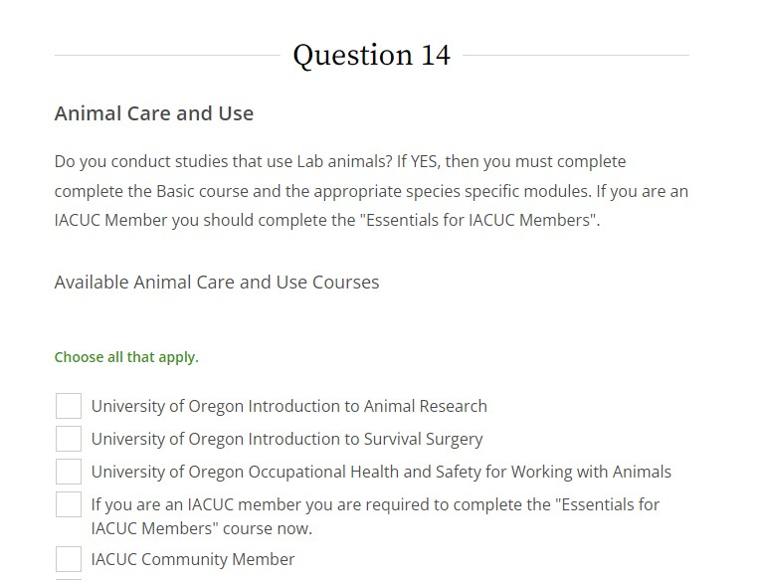

1. The courses will be listed under **“Courses ready to begin”.**
2. If you score less than 80% and need to re-take the quiz, click on “**Return to Gradebook”.** You will see the module with the low score. You can click review to return to the module, review the information and take the quiz again at the end of the material.