

# TeACS Training Checklist

## Minimum Training Required Prior to Animal Handling

### Animal Occupational Health and Safety Program

* Log on to [CITI](http://citiprogram.org/) and complete the course “University of Oregon Occupational Health and Safety for Working with Animals” ([New to CITI?](https://research.uoregon.edu/plan/training-opportunities/citi-sso)).
* Submit the “[UO Employee Animal Occupational Health Questionnaire](https://safety.uoregon.edu/sites/safety1.uoregon.edu/files/animal_ohp_questionnaire_2021.pdf)” to the UO Health Center ([Animal Occupational Health and Safety Program Info](https://safety.uoregon.edu/personnel-animal-contact-safety-program)).

### Volunteers/unpaid Students Only

* Submit the “[Volunteer Service Form](https://safety.uoregon.edu/sites/safety1.uoregon.edu/files/orm_conditions_of_volunteer_service_0.pdf)” to:
  + [IACUC@uoregon.edu](mailto:IACUC@uoregon.edu) and
  + [RiskManagement@uoregon.edu](mailto:RiskManagement@uoregon.edu)

## Additional Training in Order to Gain Facility Access

### Regulatory Training

* Use your Duck ID to log in at [TeACS](https://uoregon.sharepoint.com/sites/Terrestrial-Animal-Care-Services-TeACS?e=1%3A59bd616816b34974a954c1031a35a74a). Following the first attempt to log in, we will grant access to the website.
* Log on to [CITI](http://citiprogram.org/) and complete the course “University of Oregon Introduction to Animal Research”.
* Visit the AWS website and review the [policies](https://research.uoregon.edu/manage/integrity-compliance/animal-research/policies), then complete the [quiz](https://research.uoregon.edu/node/610502).

### Facility Specific Training

Contact [TeACS](mailto:TeACSStaff@uoregon.edu?subject=TeACS%20Access%20Info) for the following:

* 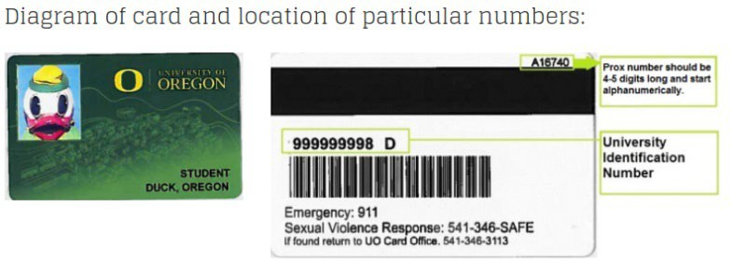Send access info:
  + Name
  + UO ID# (95#)
  + Proximity #
  + Requested 4-digit access PIN
  + Cell Phone Number
  + PI Lab
  + Role (e.g. undergrad, grad student, post doc, lab manager, etc.)
* TeACS policy training
* Facility tour and hands-on animal training
* Skills assessment

## Additional Trainings

### Surgery Training – Only as Requested by your Faculty Member

* Log on to [CITI](http://citiprogram.org/) and complete the course “University of Oregon Introduction to Survival Surgery”.
* Contact the Attending Veterinarian, [Dr. Kathy Snell](mailto:snellk@uoregon.edu) for:
  + Hands-on surgical training
  + Surgical assessment

### Lab/Protocol-Specific Training

* Read the protocol you have been added to ([How to view protocols in RAP](https://research.uoregon.edu/sites/default/files/2024-09/How%20to%20view%20protocols%20in%20RAP_0.pdf)).
* Contact your lab supervisor.

### Other TeACS Trainings

Contact [TeACS](mailto:TeACSStaff@uoregon.edu?subject=TeACS%20Training%20Request) for the following:

* Food and Fluid Regulation – Required for anyone planning on working with animals that are having their food/fluid regulated
* Colony Management – Required for individuals that are planning on maintaining breeding colonies, weaning, or performing permanent identification techniques on their rodents
* Autoclave use training – Required prior to utilization of autoclaves
* CO2 Euthanasia Training – Required prior to utilizing the TeACS CO2 euthanasia stations
* Other technique trainings (e.g. injections, blood draws, organ harvest, oral gavage, cervical dislocation) performed at user request